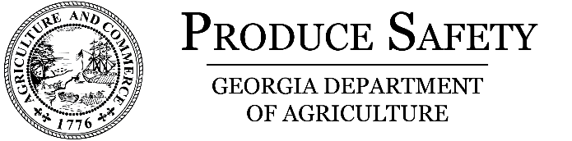 |  |  | On-Farm Readiness Review Voluntary Registration
What is an On-Farm Readiness Review?
An On-Farm Readiness Review, or OFRR, is a voluntary program offered by the Georgia Department of Agriculture Farm Safety Program. An OFRR consists of a non-regulatory, pre-inspectional visit to farms growing covered produce. An OFRR is NOT an inspection but is about educating before regulating. The goal of an OFRR is to provide farmers with useful information so they can comply with the federal Food Safety Modernization Act.
If you are interested in participating in the On-Farm Readiness Review program, please complete the form below and send to Stephany.britt@agr.georgia.gov.
If you have any additional questions, please contact the Produce Safety Program at (229)-726-8617.

Farm Name:
Physical Address:
 |  | Street |  | City |  |  |  | Zipcode | County
Farm Phone: | ( ) - |  | Farm Email:
POC Name: |  |  |  |  | POC Title:
POC Name: | First |  | Last
POC Phone: | ( ) - |  | POC Email:
POC’s preferred mode of contact? |  |  | ☐ Email | ☐ Phone |  | ☐ Mail

Commodities Grown:

